Smart Portable Irrigation Advisor

Project Documentation

1️⃣ Project Overview
Modern farmers often irrigate based on visual estimation, leading to overwatering, underwatering, or wasted water resources. This device is a portable, multi-point, offline IoT irrigation advisor that calculates field-specific water requirements using soil and environmental data.
Key features:
- Multi-point soil moisture measurement (3–4 points per session)
- Environmental sensing (temperature, humidity, light)
- Soil water balance calculation (TAW, RAW, ETc)
- Crop-specific configuration via BLE mobile app
- Offline working, persistent storage of calibration and crop data
- Irrigation suggestion notifications via BLE

2️⃣ Objectives & Problem Statement
Problem: Farmers lack precise water requirement data; existing solutions are either expensive, require continuous connectivity, or focus on farm-wide irrigation without field-level accuracy.

Objective:
Create a portable, offline device that can:
- Measure soil and environmental parameters at multiple points.
- Calculate available water and irrigation requirement.
- Provide accurate irrigation advice.
- Be configurable for different crops and field conditions.
- Store historical measurements and crop parameters.

3️⃣ Hardware Components

Component | Purpose
ESP32 | Microcontroller, BLE, processing, offline calculations
DHT22 | Ambient temperature & humidity sensor
DS18B20 | Soil temperature sensor
Capacitive Soil Moisture Sensor (v2.1) | Soil moisture measurement
Ambient Light Sensor | Solar radiation approximation for ETo calculation
Push Button | Manual trigger / calibration confirmation
NVS (ESP32 Internal Storage) | Stores calibration, crop config, and soil water

4️⃣ Sensor Calibration & Measurement Techniques
Soil Moisture Calibration:
- Dry Soil Calibration: Insert sensor into completely dry soil → record raw ADC value (dryRaw).
- Wet Soil Calibration: Insert sensor into fully saturated soil → record raw ADC value (wetRaw).
- Convert ADC reading to percent moisture: Moisture Percent = ((Raw - DryRaw)/(WetRaw - DryRaw)) * 100.
Field Capacity (FC) Calibration:
- Insert sensor into irrigated field after drainage.
- Measure raw soil moisture → convert to percent (FC_percent).
- Permanent Wilting Point (PWP) = 50% of FC_percent.
- TAW (Total Available Water) =
(FC_percent - PWP_percent)/100 * RootDepth_mm.
- RAW (Readily Available Water) = TAW * P.
5️⃣ Firmware Logic & Flow Diagram
Stepwise Firmware Flow:
- Trigger Session → BLE command or Button press
- Environmental Measurement → Measure temperature, humidity, light once
- Multi-Point Soil Moisture:
- Prompt farmer for each point → wait for button press
- Measure moisture → store in array
- Average Soil Moisture → calculate measured water in mm
- Soil Water Balance → update SoilWater_mm with ETc & measured water
- Irrigation Suggestion → check if SoilWater_mm <= RAW → send BLE message
- End Session → store values in NVS
Flow Diagram:
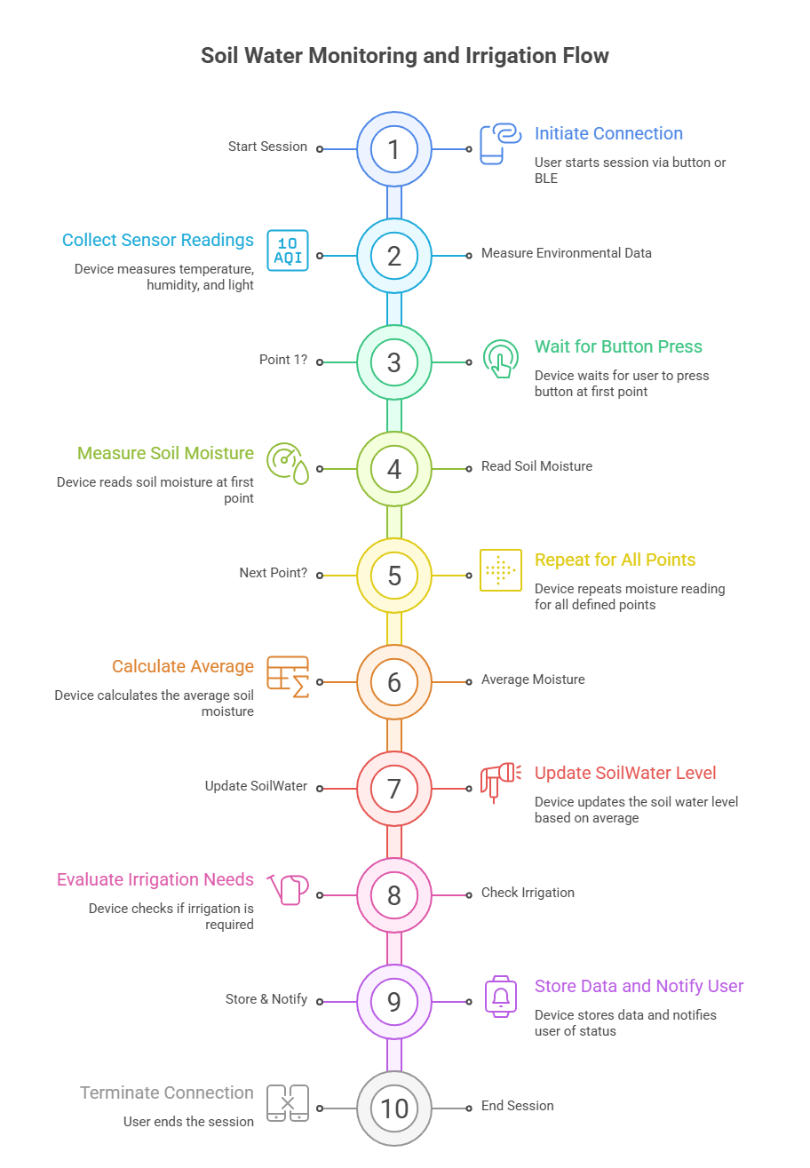
Parameter | Formula / Explanation
Moisture Percent | ((Raw - DryRaw)/(WetRaw - DryRaw)) * 100
Field Capacity (FC) | Measured moisture at drained field
PWP | 0.5 * FC
TAW (Total Available Water) | (FC - PWP)/100 * RootDepth
RAW (Readily Available Water) | TAW * P
ETo (Simplified Hargreaves) | 0.5 * (AirTemp + 17.8) * LightFactor
ETc | ETo * Kc
SoilWater_mm | SoilWater_mm = 0.7*SoilWater_mm + 0.3*MeasuredWater_mm

7️⃣ Code Explanation (Key Sections)
- BLE Setup: Handles asynchronous commands via callbacks.
- Button ISR: Triggers session start and point confirmation.
- Multi-Point Measurement Loop: Waits for button press, reads soil moisture, stores in array, averages values.
- Soil Water Balance: Computes ETc, updates SoilWater_mm, checks irrigation.
- Calibration: Moisture & Field Capacity, persistent storage.

8️⃣ BLE & User Interaction

Action | Trigger | Response
Start Measurement | BLE / Button | Device measures env + multi-point soil moisture
Configure Crop | BLE JSON | Device measures env + multi-point soil moisture
Calibrate Moisture | BLE | Guide through dry/wet calibration
Calibrate FC | BLE | Guide through field capacity calibration
Get Status | BLE | Send soil & environmental data

9️⃣ Operational Workflow (Farmer Use)
- Turn on device → BLE ready
- Start measurement via app or button
- Insert sensor at Point 1 → press button → repeat for all points
- Device averages soil moisture, computes soil water balance
- Device sends irrigation suggestion via BLE
- Data stored for history & crop management

1️⃣0️⃣ Future Improvements / Adaptive Learning
- Auto-TAW adaptation based on repeated measurements
- Dynamic Kc adjustment based on crop growth stage
- Offline logging for trend analysis
- Battery optimization: sleep mode between measurements
- Optional GSM module for cloud alerts

